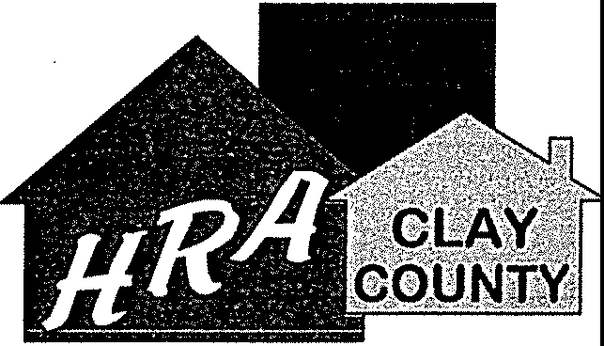
Clay County HRA
116 Center Avenue East
P.O. Box 99
Dilworth, Minnesota 56529

Phone: 218-233-8883
Toll Free: 1-877-460-5280
Fax: 218-233-9491
Email: claycohra@claycohra.com

Regular & Annual Meeting Agendas
Housing & Redevelopment Authority of Clay County, Minnesota 9:30 a.m. Regular Meeting
10:00 a.m. Annual Meeting Tuesday, February 19, 2019 HRA Offices
116 Center Ave E, Dilworth, MN 56529
The public may participate remotely along with Commissioner Les Bakke at 1021 W. Camino Sagasta, Green Valley, AZ 85622.

- Roll Call & Introductions (9:30a.m.)

2. Agenda (9:35a.m.)
- Minutes from December Meeting (9:40 a.m.)
- Citizens to be Heard (9:45 a.m.)
- Treasurer's Report (9:45a.m.)

- Project Updates & Potential New Projects (9:50a.m.)
7. Other (9:55a.m.)
  - Shutdown impacts
  - MN NAHRO Day at the Capitol recap
C. Other

- Adjourn Regular Meeting/Annual Meeting called to order (10:00 a.m.J
- Review of Reserve Balances as of 12/31/2018 (10:05 a.m.)
- Election of Officers for 2019 (10:10 a.m.)
- Meeting dates for upcoming year (10:15 a.m.)

- Review of location of agency bank accounts (10:20 a.m.)

- Delegation of Authority to Executive Director (10:25 a.m.)

- Conducting Business in Accordance with Core Values (10:30 a.m.)

- Adjourn Annual Meeting (10:35 a.m.)

'The mission of the Clav Countv HRA is to strenqthen and revitalize communities by providing development opportunities, quality housing and services.

